CELTECH COLLEGE - OLONGAPO

LE CHARME SUITES
INTEGRATED HOTEL MANAGEMENT SYSTEM
  - Project Documentation and Technical Report

IPT101 - Integrative Programming Technologies
Academic Year 2026-2027

Prepared by
Kristine Kaye Danan
John Daryl Percival
Kian Josh Danan
Seanne Ynna Alonzo
Markus Neil Turla

Submitted to
Engr. Caroline B. Paule

October 2026

Executive Summary
Le Charme Suites Integrated Hotel Management Portal (IHMP) is a role-based web application developed to coordinate hotel operations through one shared local database. It supports four staff roles: Administrator, Receptionist, Billing, and Housekeeping. The portal connects guest records, the verified 45-room property profile, encoded room inventory and status, reservations, online booking requests, check-in and check-out, billing transactions, housekeeping monitoring, reports, account management, printable guest documents, and controlled data exchange.
The implemented portal uses Laravel 13.34.0 on PHP 8.4.22, server-rendered Blade templates, HTML, CSS, JavaScript, Eloquent ORM, and SQLite. Authentication uses Laravel sessions, password hashing, CSRF protection, validation, role middleware, work-email rules, and password-reset pages. Operational dashboards query stored records instead of displaying invented cash, tax, inventory, or room-status figures.
Verification was performed against the running source code and test database rather than template assumptions. On October 20, 2026, the automated feature suite completed successfully with 95 tests and 1,427 assertions. The portal is suitable as an academic prototype and local network demonstration. Before live hotel deployment, the team must obtain authorized access to the hotel's production booking platform, complete staff acceptance testing, harden deployment settings, and establish backup, recovery, and security procedures.

Document Status
Item | Verified Value
System | Le Charme Suites Integrated Hotel Management Portal
Framework | Laravel 13.34.0
Runtime | PHP 8.4.22
Database | SQLite (database/database.sqlite)
Primary repository | https://github.com/krstnkye/le-charme-suites-ihms
Verification date | October 20, 2026
Automated result | 95 tests passed; 1,427 assertions

Table of Contents
Executive Summary 2
Document Status 2
Table of Contents 3
1. Introduction 5
1.1 Project Context 5
1.2 General Objective 5
1.3 Specific Objectives 5
1.4 Significance of the Project 5
1.5 Scope 5
1.6 Limitations 6
1.7 Terminology 6
2. Review of Related Systems and Technologies 7
2.1 Related Hotel Management Platforms 7
2.2 Supporting Technologies 7
2.3 Comparative Analysis 7
2.4 Synthesis and Identified Gap 7
3. Technical Background 8
3.1 Technology Stack 8
3.2 Application Architecture 8
3.3 Database Design 8
3.4 Data Integrity and Business Rules 8
3.5 Internal Integration 9
3.6 Security Controls 9
4. Methodology, Development, and Evaluation 10
4.1 Development Method 10
4.2 Functional Requirements 10
4.3 Nonfunctional Requirements 10
4.4 Role and Access Matrix 11
4.5 Major Use Cases 11
4.6 Integration Trace 11
4.7 Development and Version Control 11
4.8 Test Strategy and Results 12
4.9 Issues Corrected During Review 12
5. Developed System 13
5.1 Authentication Interface 13
5.2 Administrator Command Center 14
5.3 Reception / Front Desk Workspace 15
5.4 Reservation Management 16
5.5 Housekeeping Workspace 17
5.6 Billing Workspace 18
5.7 Online Booking and Integration Center 19
5.8 Printable Guest Documents and Data Reports 20
6. Deployment and Operation 21
6.1 Minimum Development Requirements 21
6.2 Setup on a New Computer 21
6.3 Demonstration Accounts 21
6.4 Backup and Recovery 21
6.5 Deployment Status 21
7. Results and Discussion 22
7.1 Objective Traceability 22
7.2 Discussion 22
7.3 Acceptance Summary 22
8. Conclusions and Recommendations 23
8.1 Conclusion 23
8.2 Recommendations 23
8.3 Proposed Future Enhancements 23
References 24
Appendices 25
Appendix A. Repository and Source Code 25
Appendix B. Verified Database Schema 25
Appendix C. Sample Input and Output 25
Appendix D. Quick User Guide 25
Appendix E. Process and Data Flow 25
Appendix F. Screen Layouts 25
Appendix G. Automated Test Evidence 25
Appendix H. Generated Reports and Records 26
Appendix I. Development Photographs 26
Appendix J. Curriculum Vitae 26
Appendix K. AI Assistance Declaration 26
Project Information Sheet 27

1. Introduction

1.1 Project Context
Hotel operations depend on coordinated information from front desk, room management, billing, and housekeeping. When these activities are recorded separately, staff can encounter duplicate entries, inconsistent room availability, delayed billing updates, and limited operational visibility. The Le Charme Suites IHMP was built as one browser-based portal to reduce these gaps and demonstrate integrated programming concepts in a realistic hospitality setting.

1.2 General Objective
To design, implement, and evaluate a role-based integrated hotel management portal that connects guest, room, reservation, online booking, arrival, departure, billing, housekeeping, reporting, and staff-account workflows through shared data.

1.3 Specific Objectives
- Maintain a single database for guests, rooms, reservations, arrivals, departures, transactions, and room status history.
- Provide role-appropriate dashboards and navigation for Administrator, Receptionist, Billing, and Housekeeping staff.
- Keep room status synchronized with reservation, check-in, check-out, and housekeeping activities.
- Record financial events associated with reservations, arrivals, departures, and direct hotel transactions.
- Provide administrators with cross-department monitoring, account controls, integration records, reports, and audit views.
- Apply authentication, authorization, validation, password hashing, and CSRF protection.
- Verify the major workflows through repeatable automated feature tests.

1.4 Significance of the Project
Stakeholder | Value Provided
Hotel administrators | Central account, access, room, reservation, transaction, report, audit, and configuration oversight.
Reception/front desk | Guest registration, room availability, reservation processing, and arrival/departure coordination.
Billing personnel | Departure settlement, transaction review, billing reports, and account-based financial monitoring.
Housekeeping staff | Room readiness, cleaning priorities, service requests, maintenance reporting, and status history.
Students and evaluators | A working example of MVC architecture, database integration, role-based access, testing, and team version control.

1.5 Scope
- Session-based login and logout for four staff roles.
- Guest registration and record maintenance.
- Room inventory, type, rate, capacity, availability, and status management.
- Reservation creation and monitoring.
- Check-in and check-out processing with linked status and transaction records.
- Billing transaction, history, and report views.
- Housekeeping dashboards, task-oriented views, room status monitoring, and issue reporting interfaces.
- Online booking requests, secure API endpoints, transfer reports, and integration event records.
- Administrator user, role, permission, audit, report, and system-setting interfaces.
- Local development deployment and GitHub-based source collaboration.

1.6 Limitations
- The portal includes a public demonstration booking page and a protected booking/data API. It is not connected to Le Charme Suites' live production booking provider because the hotel has not supplied administrator credentials, API documentation, or webhook access. Payment gateway, SMS, email delivery, and accounting-system integration are outside the current scope.
- Updates are request-and-refresh based; the system does not currently use WebSockets or push notifications.
- Housekeeping pages use encoded room and room-status history records. Separate inventory purchasing, linen stock, chemical stock, and supplier modules were intentionally removed because verified hotel records and requirements for those functions were not available.
- The permission matrix is stored in the session and is not yet persisted to a database table.
- Staff registration validates the approved work-email domain and returns newly registered users to the login page. For live deployment, privileged account creation should still require administrator approval and verified staff identity.
- The current SQLite database and local server setup support development, offline use on one computer, and local network demonstrations. They are not yet a hardened, highly available production deployment.
- No formal load test, penetration test, disaster-recovery drill, or production uptime measurement has been completed.

1.7 Terminology
Term | Meaning in This Project
Guest bill | The running charges and settlement information linked to a guest stay; used instead of the less familiar term 'folio'.
Billing record | A summarized record of charges, payment status, and related guest/reservation information.
Transaction | A specific financial event such as a reservation charge, check-in record, check-out settlement, payment, refund, or adjustment.
Room status | Available, reserved, occupied, cleaning, or maintenance.
Role | The staff access category used by middleware to authorize modules.

2. Review of Related Systems and Technologies

2.1 Related Hotel Management Platforms
Oracle Hospitality OPERA Cloud is a commercial hospitality platform covering property operations, guest profiles, reservations, front desk, rooms, and related hotel functions. It demonstrates the industry value of connecting operational records instead of maintaining isolated departmental files.
Cloudbeds presents a property management system designed to centralize reservations, guest information, room assignment, payments, and reporting. Its emphasis on a unified workspace supports the same core integration objective pursued by this academic project, although the Le Charme Suites IHMP is smaller and locally deployed.
Mews provides cloud hotel management products for reservations, operations, guest journeys, payments, and business intelligence. It illustrates the benefit of role-specific operational tools connected to shared data and management visibility.

2.2 Supporting Technologies
Laravel supplies routing, middleware, form validation, sessions, authentication integration, Blade templating, database migrations, Eloquent ORM, and an automated testing foundation. PHP provides the server-side runtime. SQLite supplies a self-contained relational database suitable for development, classroom demonstration, and easy project transfer because the database is stored in a single file.
The OWASP Top 10 is used as a security reference for risks such as broken access control, authentication failures, injection, security misconfiguration, and insufficient logging. The project addresses several baseline controls through role middleware, Eloquent parameter handling, validation, password hashing, CSRF tokens, and session regeneration, while acknowledging the additional hardening required for production.

2.3 Comparative Analysis
Capability | Commercial Platforms | Le Charme Suites IHMP
Integrated operational records | Broad multi-property capability | Implemented for core local hotel workflows
Role-based workspaces | Extensive configurable roles | Five fixed roles with middleware enforcement
Guest and reservation lifecycle | Full enterprise lifecycle | Guest, reservation, arrival, departure, and transaction records
Payments and channels | Gateway and channel integrations | Internal transaction records only
Deployment | Cloud/enterprise | Local Laravel server with SQLite
Purpose | Commercial hotel operations | Academic prototype and local operational demonstration

2.4 Synthesis and Identified Gap
The related platforms confirm that effective hotel portals depend on shared records, role-appropriate interfaces, synchronized room and financial states, and controlled integration. Enterprise products exceed the scope of an IPT101 prototype, so this project implements the essential patterns in a Laravel codebase the team can explain, modify, test, and demonstrate. The remaining gap is production depth: hotel-authorized external integration, persistent granular permissions, dedicated service-request entities, operational hardening, and scale testing.

3. Technical Background

3.1 Technology Stack
Layer | Technology | Purpose
Client | Web browser | Displays role dashboards and submits forms.
Presentation | Laravel Blade, HTML, CSS, JavaScript | Server-rendered interfaces, responsive layouts, and lightweight interactions.
Application | Laravel 13.34.0 | Routing, middleware, controllers, validation, sessions, views, and tests.
Runtime | PHP 8.4.22 | Executes server-side application logic.
Data access | Eloquent ORM | Maps application models to relational records.
Database | SQLite | Stores users, guests, rooms, reservations, arrivals, departures, transactions, and room status logs.
Version control | Git and GitHub | Tracks team changes and supports sharing through a remote repository.

3.2 Application Architecture
The application follows Laravel's model-view-controller pattern. A browser request reaches a route, passes through authentication and role middleware, and is handled by a controller. The controller validates input and uses Eloquent models to read or update SQLite records. A Blade template then renders the response. Shared navigation and role-specific layouts improve reuse across modules.
Flow Step | Responsibility
1. Browser | Requests a page or submits a form.
2. Route | Maps the URL and HTTP method to a controller action.
3. Middleware | Confirms authentication and authorized role access.
4. Controller | Validates input and coordinates the business operation.
5. Model / Eloquent | Reads and writes relational data.
6. SQLite | Persists the application record and related status history.
7. Blade response | Returns the updated role-specific interface.

3.3 Database Design
Table | Purpose | Key Relationships
users | Login accounts and assigned roles | Referenced by authentication session
guests | Guest identity and contact details | Has reservations and transactions
rooms | Inventory, type, rate, capacity, and current status | Has reservations, transactions, and status logs
reservations | Stay dates, guest count, notes, and lifecycle status | Belongs to guest and room
check_ins | Actual arrival event and active-stay state | Links reservation, guest, and room
check_outs | Departure time, amount paid, and payment status | Links check-in, reservation, guest, and room
hotel_transactions | Financial event ledger | Optionally links guest, reservation, and room
room_status_logs | Room status audit history | Belongs to room

3.4 Data Integrity and Business Rules
- A reservation can be created only for an available room.
- Creating a reservation changes the room status to reserved and writes a status log.
- Check-in is allowed only for a reserved reservation and changes the room to occupied.
- Check-out is allowed only for an active check-in and changes the room to cleaning.
- The permitted room states are available, reserved, occupied, cleaning, and maintenance.
- Lifecycle actions create related hotel transaction records for traceability.
- Role middleware limits each staff account to its assigned operational workspace; administrators retain authorized cross-department access.

3.5 Internal Integration
Internal integration uses shared Eloquent models, relational keys, controllers, and status transitions. A protected /api/v1 interface can exchange approved room, reservation, and booking data using an integration key, request limits, idempotency safeguards, and integration event logs. The public /book page provides a safe demonstration flow. Connection to the hotel's live website remains conditional on written permission and technical credentials from its booking provider.

3.6 Security Controls
Control | Implemented Behavior | Remaining Work
Authentication | Laravel session login and logout with session regeneration | Add optional MFA and production email delivery
Passwords | Hashed model cast, minimum length validation, and password-reset token flow | Define production password policy
Authorization | auth and role middleware; Administrator bypass is intentional | Persist granular permissions
Input safety | Server-side validation and Eloquent parameter handling | Expand negative and fuzz tests
Request forgery | CSRF tokens on state-changing forms | Keep framework protections enabled
Auditability | Room status logs and transaction records | Add comprehensive user/action audit events
Configuration | Local environment is functional | Disable debug and protect secrets in production
Integration API | Bearer integration key, throttling, idempotent booking requests, and event logs | Use hotel-issued credentials and rotate secrets in production

4. Methodology, Development, and Evaluation

4.1 Development Method
The project used iterative prototyping. The team first identified departmental roles and core hotel workflows, then implemented shared data models and routes, created role-specific user interfaces, connected the interfaces to real database records, and repeatedly tested and refined behavior. GitHub supported version control and team distribution. This method was appropriate because interface feedback and business rule clarification occurred throughout development.
- Requirements analysis: identify actors, records, permissions, and hotel lifecycle states.
- Data design: create migrations and model relationships for shared operational records.
- Core implementation: build authentication, middleware, controllers, validation, and lifecycle actions.
- Interface prototyping: develop role-specific dashboards and operational pages.
- Integration: connect pages to the same SQLite data and synchronize state transitions.
- Verification: run feature tests, inspect routes, review the database, and perform browser checks.
- Documentation: align the report with the verified implementation and disclose remaining limitations.

4.2 Functional Requirements
ID | Requirement | Implementation Status
FR-01 | Authenticate users and route them to their assigned workspace. | Implemented and tested
FR-02 | Enforce module access by role. | Implemented and tested
FR-03 | Create, view, update, and delete guest records where authorized. | Implemented
FR-04 | Manage room inventory, type, rate, capacity, and status. | Implemented and tested
FR-05 | Create and monitor reservations using available rooms. | Implemented and tested
FR-06 | Process check-in and update room state. | Implemented
FR-07 | Process check-out, payment status, and room cleaning state. | Implemented
FR-08 | Record and display hotel transactions. | Implemented
FR-09 | Provide housekeeping monitoring and task-oriented views. | Partially persisted; UI and room-status data implemented
FR-10 | Accept and track online booking requests through the shared reservation database. | Implemented and tested
FR-11 | Allow administrators to manage users and protect critical accounts. | Implemented and tested
FR-12 | Provide reports and records based on stored operational data. | Implemented

4.3 Nonfunctional Requirements
Category | Requirement | Current Evidence
Usability | Consistent role navigation and readable operational status. | Shared layouts and role-specific dashboards
Security | Authenticated access, role authorization, hashed passwords, CSRF, and validation. | Framework controls and access tests
Maintainability | MVC separation, migrations, named routes, and reusable Blade layouts. | Laravel project structure
Portability | Run on another computer with PHP, Composer, SQLite, and a browser. | Repository and setup process
Reliability | Protect valid lifecycle transitions and prevent unauthorized writes. | Feature tests and validation rules
Performance | Responsive for classroom/local demonstration data volumes. | Browser verification; no formal load benchmark yet

4.4 Role and Access Matrix
Module | Admin | Reception | Billing | Housekeeping
Dashboard | Manage | Use | Use | Use
Guests | Manage | Manage | Related view | No
Rooms | Manage | View/use | Related view | Status use
Reservations | Manage | Manage | Related view | No
Check-in | Manage | Process | View | No
Check-out | Manage | Process | Process | No
Transactions | Manage | No | Use | No
Housekeeping | Manage | No | No | Use
Reports | View/export UI | Limited | Use | Use
Users/settings | Manage | No | No | No

4.5 Major Use Cases
Use Case | Primary Actor | Precondition | Result
Sign in | All users | Active account exists | Authenticated session and role dashboard
Create reservation | Reception/Admin | Guest data and available room | Reservation, reserved room, status log, transaction
Check in guest | Reception/Admin | Reserved reservation | Active check-in, occupied room, log, transaction
Check out guest | Reception/Billing/Admin | Active check-in | Departure record, payment state, cleaning room, log, transaction
Update room status | Housekeeping/Admin | Authorized room workflow | Current status and timestamped history
Submit online booking | Public guest or authorized website | Available encoded room and valid guest details | Pending reservation in the shared database and integration event history
Manage account | Admin | Administrator access | Created, updated, deactivated/deleted account subject to safeguards

4.6 Integration Trace
Business Event | Records Written | Visible Consequence
Reservation created | guests (when new), reservations, rooms, room_status_logs, hotel_transactions | Room becomes reserved and appears in relevant dashboards
Guest checked in | check_ins, reservations, rooms, room_status_logs, hotel_transactions | Room becomes occupied; arrival is recorded
Guest checked out | check_outs, check_ins, reservations, rooms, room_status_logs, hotel_transactions | Room becomes cleaning; settlement is recorded
Housekeeping status changed | rooms, room_status_logs | Readiness changes across authorized department dashboards
User account changed | users | Authentication and role access reflect the new account state
Online booking received | guests, reservations, rooms, hotel_transactions, integration_events | Request appears in the front desk reservation and confirmation workflow

4.7 Development and Version Control
The source is maintained in Git and shared through GitHub at https://github.com/krstnkye/le-charme-suites-ihms. Team members should pull before starting work, create focused commits, run the automated suite, resolve conflicts carefully, and push only verified changes. Environment secrets and local database contents must not be committed.

4.8 Test Strategy and Results
Testing combined automated Laravel feature tests with manual browser verification. The automated suite was run on October 20, 2026 and completed with 95 passing tests and 1,427 assertions. Coverage includes authentication, password reset, work-email rules, role routing, dashboards, room and reservation workflows, check-in and check-out, printable guest documents, online booking, API authorization, integration reliability, and the removal of unsupported housekeeping inventory pages.
Test Area | Expected Result | Result
Role login redirects | Each seeded role reaches its intended workspace | PASS
Unauthorized role access | Forbidden modules return HTTP 403 | PASS
Administrator user creation | Valid staff account is persisted | PASS
Administrator user update | Account fields and role can be updated | PASS
Protected account deletion | Self/active/last administrator safeguards apply | PASS
Room creation | Room is persisted and appears in room management | PASS
Reservation creation | Reservation and linked room state are updated | PASS
Reservation details | Stored reservation information is displayed | PASS
Housekeeping workspace | Authorized user can reach assigned housekeeping pages | PASS
Billing workspace | Billing role pages load with authorized data | PASS
Removed housekeeping inventory pages | Old linen and supply URLs return HTTP 404 and no menu link remains | PASS
Dashboard real-data checks | Property totals, reservation lists, and guest bills use configured facts and stored records | PASS
Online booking and API | Protected and public booking flows create one shared reservation and prevent duplicates | PASS
Printable guest documents | Registration card, guest bill, and receipt use dedicated print views | PASS

4.9 Issues Corrected During Review
Issue in Draft or Earlier Build | Correction / Verified Position
Documentation identified MySQL as the database. | Corrected to SQLite based on configuration and database/database.sqlite.
Some text implied external APIs and true live synchronization. | Corrected to internal Laravel integration and request/refresh updates.
Cashier terminology conflicted with the department UI. | User-facing documentation uses Billing while retaining cashier as the internal role identifier where applicable.
The word 'folio' was unclear to users. | Replaced with guest bill or billing record except where explaining legacy terminology.
Dashboard cards used unsupported estimates. | Replaced invented cash, tax, deposit, and inventory values with stored records and verified property facts.
Housekeeping features appeared fully persisted. | Clarified which pages use rooms/status logs and which need dedicated tables.
Template sections used future tense and placeholders. | Rewritten using verified implementation and test evidence.

5. Developed System

5.1 Authentication Interface
The login screen allows the user to select a hospitality role and enter an account identifier and password. The server authenticates the account, regenerates the session, and redirects to the role workspace.
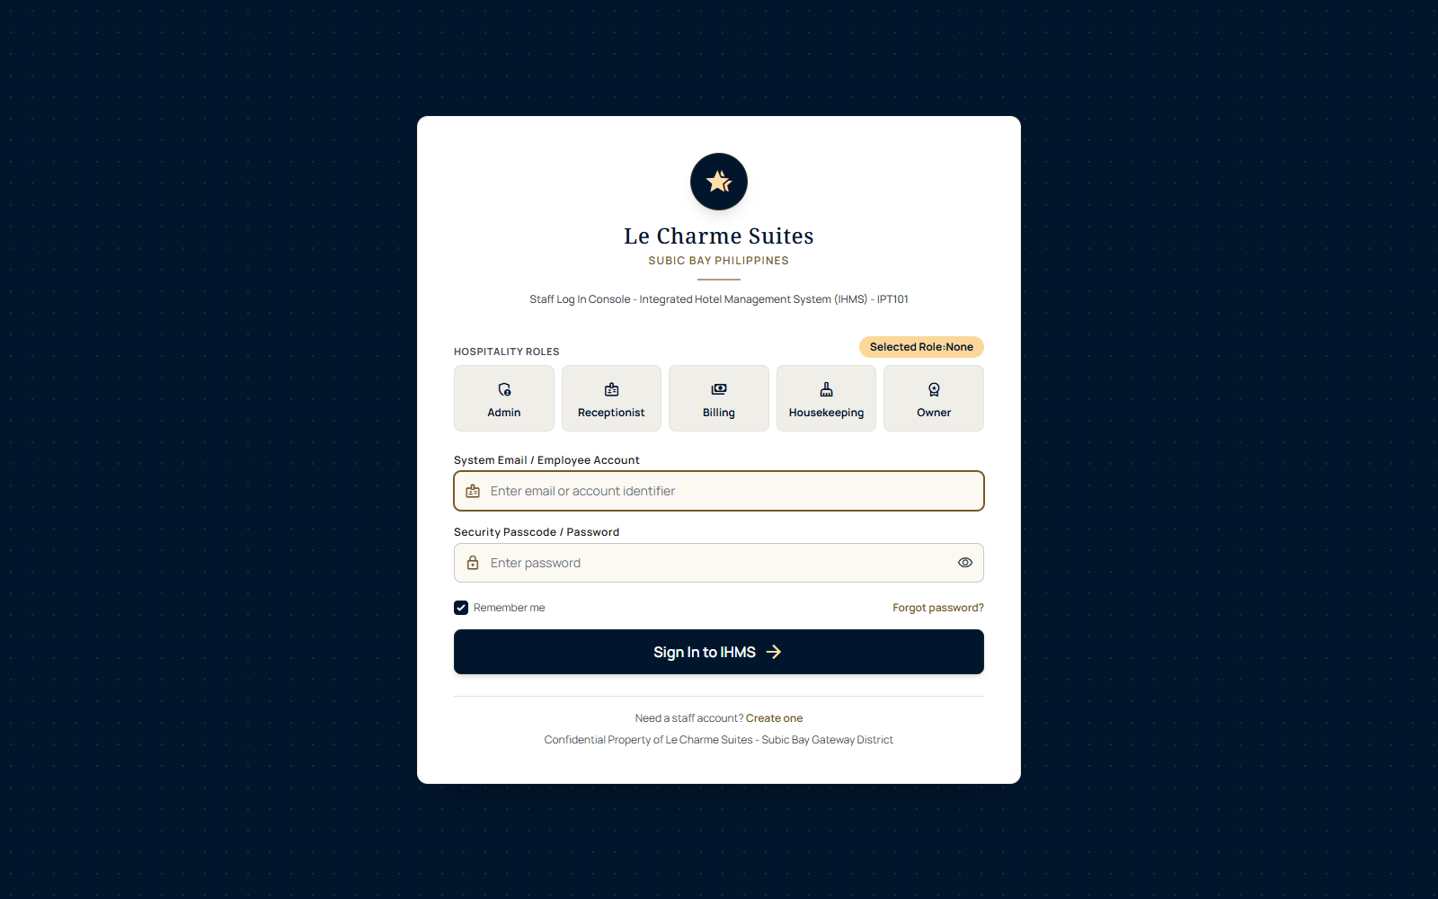
Figure 1. Role-based login interface.

5.2 Administrator Command Center
The Administrator dashboard summarizes occupancy, reservation flow, staff accounts, exceptions, and linked operational subsystems. It provides the broadest access, including accounts, rooms, reservations, billing, reports, audit views, and settings.
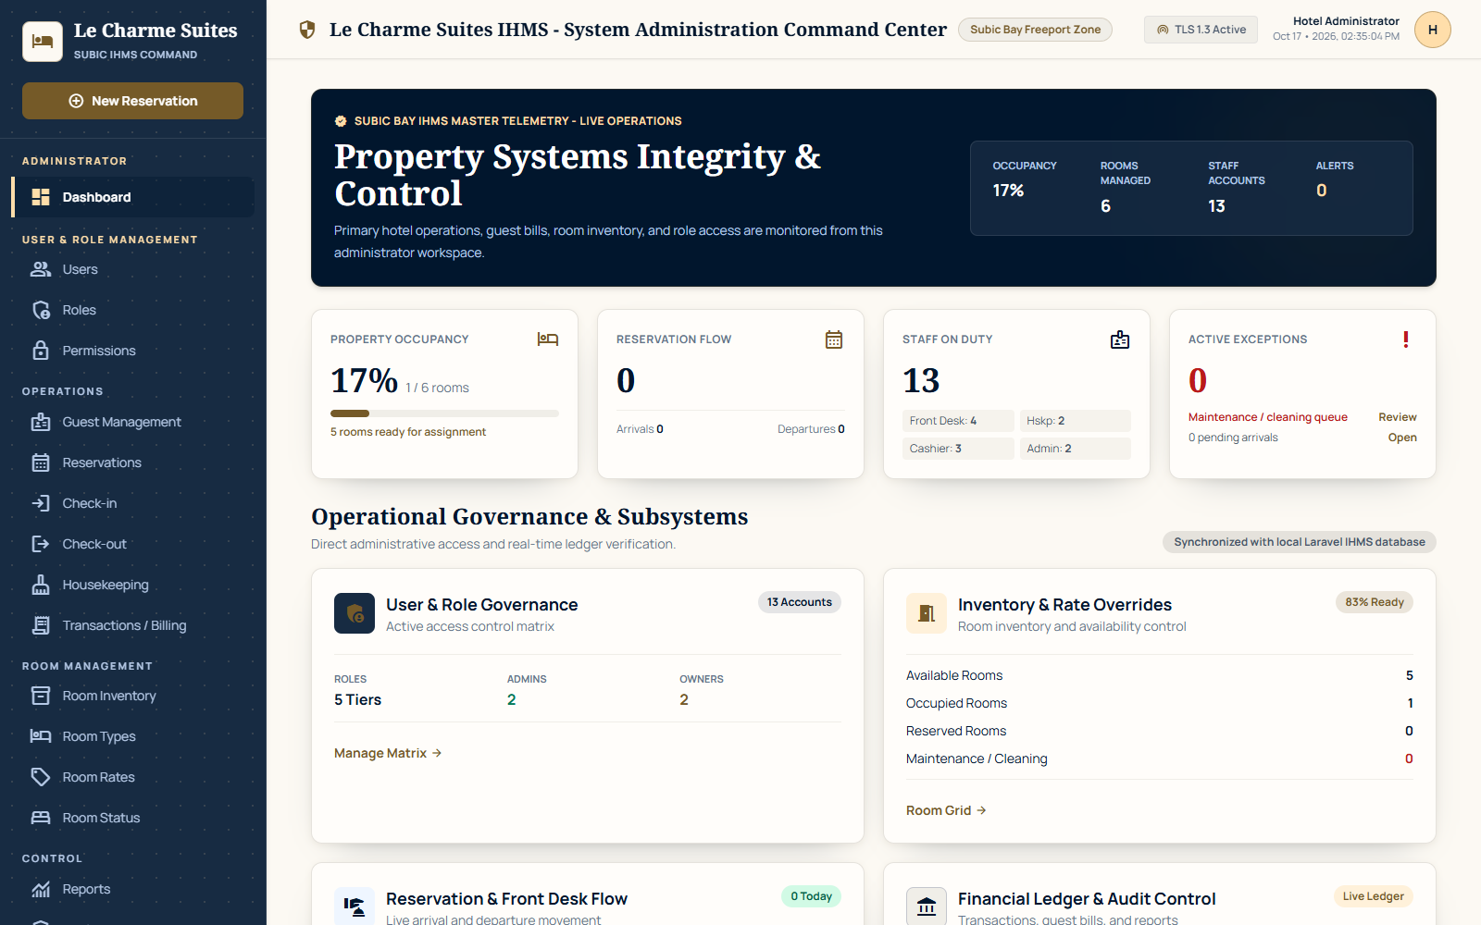
Figure 2. Administrator command center using current database values.

5.3 Reception / Front Desk Workspace
The reception workspace supports guest handling, room availability, reservations, and arrival/departure processing. Its interface focuses on daily front-desk tasks rather than system administration.
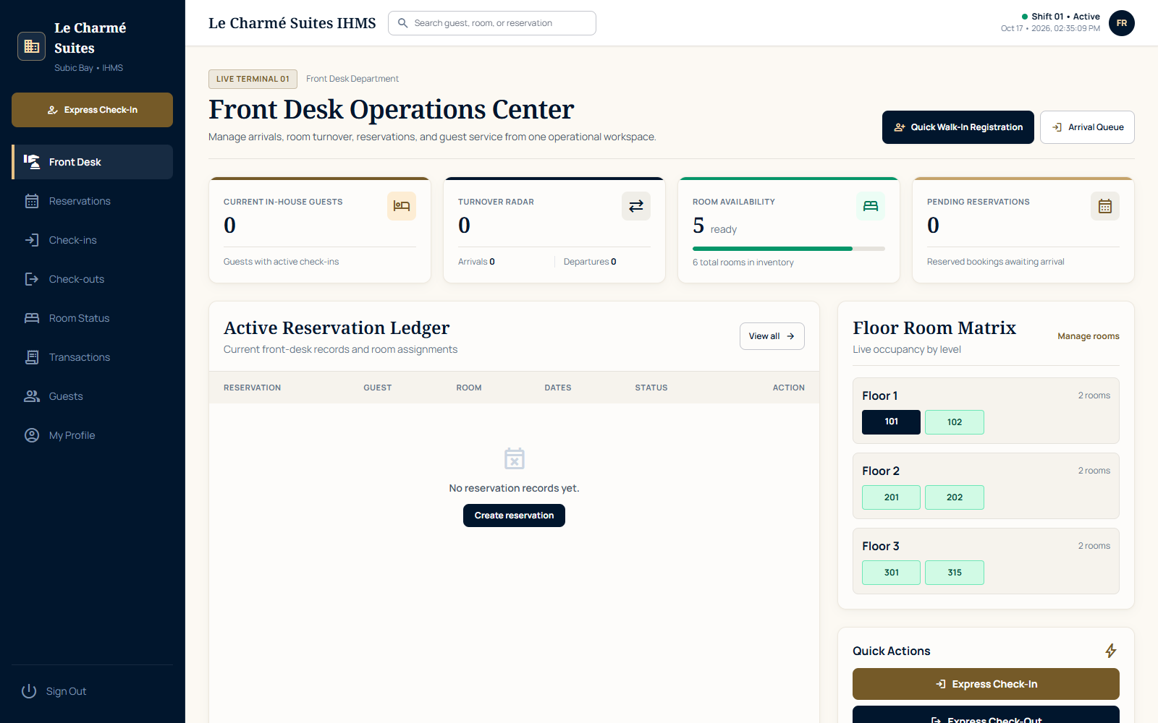
Figure 3. Reception and front desk dashboard.

5.4 Reservation Management
Reservation screens use real guest, room, and reservation records. Search and status information help staff locate bookings, while validated actions preserve room availability rules.
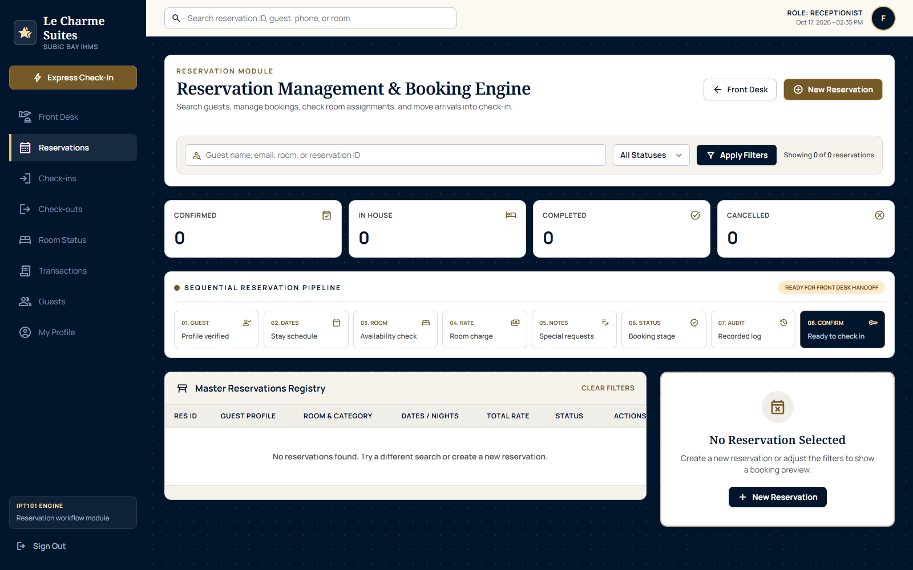
Figure 4. Reservation management interface.

5.5 Housekeeping Workspace
Housekeeping uses room status, assigned rooms, inspections, cleaning tasks, priority rooms, completed work, service and maintenance requests, lost and found, reports, notifications, and profile access. Counts and work lists come from encoded room and room-status history records. The portal separately displays the verified property total of 45 rooms so the official hotel profile is not confused with the smaller set of currently encoded operational room records.
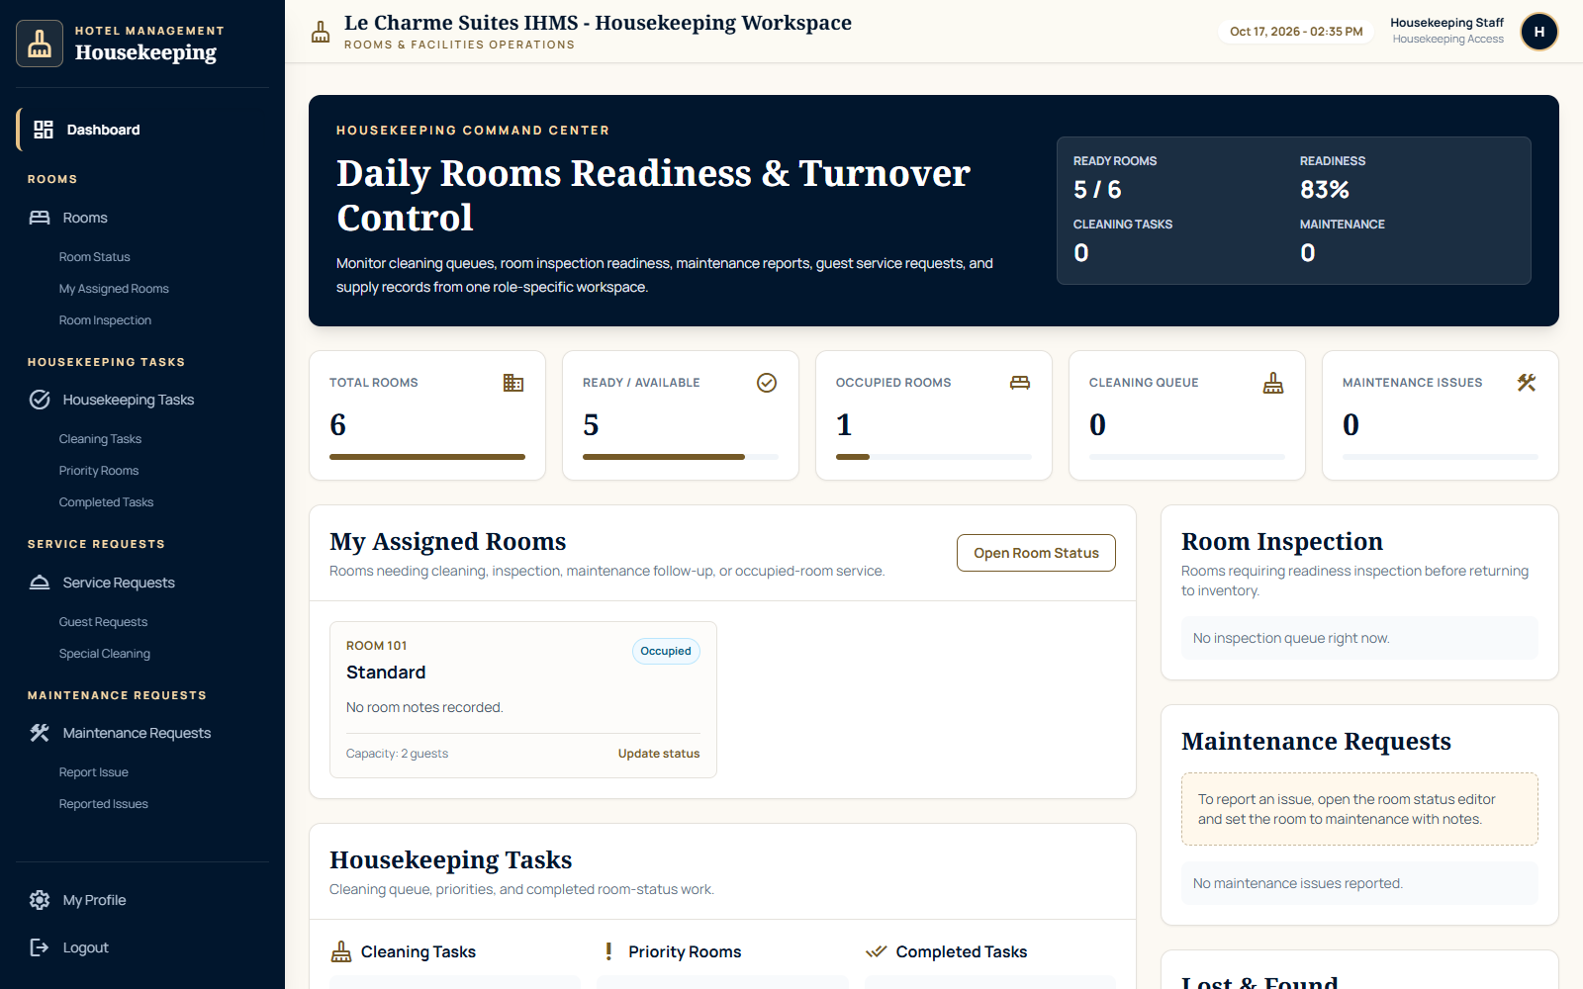
Figure 5. Housekeeping dashboard and operational navigation.

5.6 Billing Workspace
The Billing workspace presents guest bills, departures for payment, recorded charges, payment status, transaction activity, receipt printing, and report access. Room charges are calculated from saved room rates and stay dates; additional charges and payments come from stored transaction and check-out records. Unsupported starting-cash, tax, deposit, and payment-method estimates were removed.
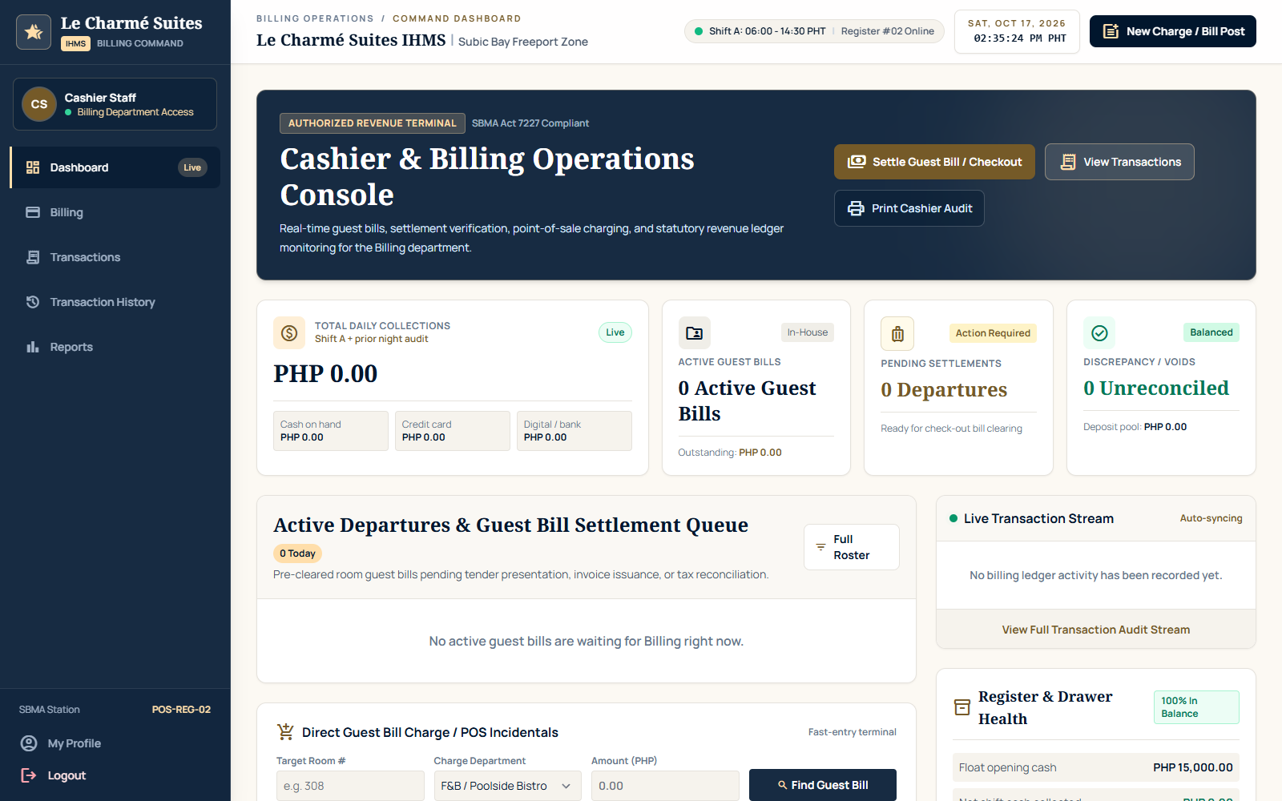
Figure 6. Billing operations dashboard.

5.7 Online Booking and Integration Center
The portal provides a public demonstration booking page and a protected API endpoint for approved booking sources. New requests are validated against room availability, saved to the shared reservation database, recorded in the integration history, and shown to front desk staff for confirmation. This demonstrates the intended connection without claiming access to the hotel's live booking provider.

5.8 Printable Guest Documents and Data Reports
The portal provides dedicated print views for guest registration cards, itemized guest bills, and check-out receipts. Administrative transfer reports and controlled CSV or JSON exports document movement between approved platforms. The browser prints only the document layout, not the surrounding dashboard.

6. Deployment and Operation

6.1 Minimum Development Requirements
Requirement | Recommended Version / Note
Operating system | Windows 10/11, macOS, or Linux
PHP | PHP 8.3 or later with SQLite and common Laravel extensions
Composer | Current Composer 2 release
Database | SQLite; no XAMPP or MySQL server is required
Browser | Current Microsoft Edge, Google Chrome, or Firefox
Source control | Git; GitHub account for collaboration
Editor | Visual Studio Code recommended; PHP Intelephense and Laravel Blade support are helpful but optional

6.2 Setup on a New Computer
- Install Git, PHP 8.3 or later, Composer, and Visual Studio Code.
- Clone https://github.com/krstnkye/le-charme-suites-ihms and open the project folder in Visual Studio Code.
- Run composer install in the project terminal.
- Copy .env.example to .env if .env is absent, then run php artisan key:generate.
- Create database/database.sqlite if it is absent.
- Run php artisan migrate --seed to create the schema and local demonstration accounts.
- Run php artisan test and confirm the suite passes.
- Run php artisan serve and open http://127.0.0.1:8000 in a browser.

6.3 Demonstration Accounts
Role | Email | Demonstration Password
Administrator | admin@example.com | password
Reception | receptionist@lecharme.test | password
Billing | cashier@lecharme.test | password
Housekeeping | housekeeping@lecharme.test | password

Security note: these credentials are for local demonstration only. Production accounts must use unique strong passwords and must never be committed to a public repository.

6.4 Backup and Recovery
- Commit and push source changes regularly, excluding .env and secrets.
- Back up database/database.sqlite before migrations or demonstrations that may alter data.
- Use php artisan migrate:status before and after schema changes.
- Restore source from GitHub and restore the latest verified SQLite backup when recovery is required.
- For production, replace ad hoc file copies with scheduled encrypted backups and tested restore procedures.

6.5 Deployment Status
The verified implementation runs locally with Laravel's development server. It has not yet been deployed to a public production host. A production deployment should use a supported web server, HTTPS, a protected environment file, APP_DEBUG=false, secure cookies, log rotation, backups, monitoring, and a database configuration appropriate to the expected number of concurrent users.

7. Results and Discussion

7.1 Objective Traceability
Objective | Evidence | Assessment
Centralize operational data | Eight linked business tables and shared Eloquent models | Achieved for core records
Provide role workspaces | Four authenticated department dashboards and role middleware | Achieved
Synchronize room lifecycle | Reservation, arrival, departure, and status-log updates | Achieved
Record billing events | hotel_transactions and check_out payment fields | Achieved at prototype level
Support controlled integration | Public demonstration booking, protected API, transfer reports, and integration event history | Achieved at prototype level
Protect access | Authentication, role middleware, validation, CSRF, and hashing | Achieved at baseline level
Verify workflows | 95 passing tests with 1,427 assertions | Achieved for tested scenarios
Use verified housekeeping data | Room and status records are live; unsupported linen and supply inventory was removed | Achieved for current confirmed scope

7.2 Discussion
The strongest result is the use of shared data to connect departmental behavior. Room status changes through validated reservation, arrival, departure, and housekeeping events, while online booking requests enter the same reservation records. Dashboards read those records directly, so staff see the same operational state rather than unrelated screen mockups.
The role model separates administrator, reception, billing, and housekeeping responsibilities. Automated tests provide regression evidence for role routing, protected access, account safeguards, room creation, reservation behavior, online booking, API authorization, billing calculations, printable documents, and role-specific pages.
The main remaining weakness is that only confirmed operational room records are encoded, although the property profile correctly states 45 rooms and five room types. The exact room-number list and room-type quantities still require confirmation from hotel management. The system should therefore be presented as a working academic IHMP prototype with a tested operational core, not as the hotel's live production platform.

7.3 Acceptance Summary
Criterion | Status | Comment
Application starts locally | Accepted | Laravel development server verified
Database schema and seed data | Accepted | SQLite migrations and seeded accounts verified
Core role access | Accepted | Automated authorization tests pass
Reservation lifecycle | Accepted | Database-backed create and detail behavior verified
Cross-department views | Accepted | Shared records appear in role dashboards
Production readiness | Not yet | Security hardening, persistent permissions, dedicated task entities, and deployment work remain

8. Conclusions and Recommendations

8.1 Conclusion
The Le Charme Suites IHMP successfully demonstrates integrated hotel operations through a Laravel web portal with shared relational data and role-based interfaces. It supports guest, room, reservation, online booking, arrival, departure, transaction, housekeeping monitoring, reporting, account, data-transfer, and printable-document workflows. The verified 95-test and 1,427-assertion result shows that the principal access and operational scenarios are repeatable at the current scope.
The project satisfies its academic objective as a working prototype, while the documented limitations establish a clear boundary between the present system and production hospitality software. Accurate disclosure of those limits strengthens the project because it demonstrates technical understanding and provides an achievable improvement plan.

8.2 Recommendations
- Remove privileged role selection from public registration and require administrator approval for staff accounts.
- Persist role permissions and permission overrides in normalized database tables.
- Add dedicated housekeeping task, service request, maintenance issue, lost-and-found, and notification tables after hotel staff confirm the required fields and procedures.
- Add database transactions around reservation, arrival, and departure operations so linked writes succeed or fail together.
- Implement comprehensive audit logging with actor, action, timestamp, affected record, and before/after values.
- Add password reset, email verification, optional MFA, login throttling, and a documented password policy.
- Create production deployment configuration with HTTPS, protected secrets, APP_DEBUG=false, monitoring, and automated backups.
- Expand automated coverage for validation failures, concurrency, billing calculations, report filters, and full browser journeys.
- Conduct usability testing with actual hotel staff or representative users and record measurable findings.
- Perform load, security, recovery, and accessibility testing before any live hotel use.

8.3 Proposed Future Enhancements
- Production connection to the hotel's authorized booking provider or channel manager.
- Payment gateway and official receipt integration.
- Email/SMS confirmations and staff alerts.
- Persistent real-time notifications using queues and WebSockets.
- Inventory purchasing and supplier management.
- Advanced revenue, occupancy, and housekeeping analytics.
- Multi-property support and configurable tax/rate rules.
- Mobile-optimized housekeeping task execution and offline synchronization.

References
Cloudbeds. (2026). Property management system. https://www.cloudbeds.com/property-management-system/
Laravel. (2026). Hashing. https://laravel.com/framework/docs/hashing
Laravel. (2026). Validation. https://laravel.com/framework/docs/validation
Mews. (2026). Hotel management software. https://www.mews.com/en/solutions/hotel-management-software
Mews. (2026). Products. https://www.mews.com/en/products
Oracle. (2026). Hospitality. https://www.oracle.com/hospitality/
Oracle. (2026). OPERA Cloud documentation. https://docs.oracle.com/en/industries/hospitality/opera-cloud/24.3/index.html
OWASP Foundation. (2021). OWASP Top 10. https://top10.owasp.org/2021/
PHP Documentation Group. (2026). Introduction to PHP. https://www.php.net/manual/en/introduction.php
SQLite Consortium. (2026). About SQLite. https://www.sqlite.org/about.html
Le Charme Suites IHMP development team. (2026). Project source repository. https://github.com/krstnkye/le-charme-suites-ihms

Appendices

Appendix A. Repository and Source Code
Repository: https://github.com/krstnkye/le-charme-suites-ihms. The repository contains the Laravel source, routes, controllers, models, migrations, views, tests, and project setup files. Environment secrets and machine-specific files must remain excluded from commits.

Appendix B. Verified Database Schema
The verified schema contains users, cache, jobs, guests, rooms, reservations, check_ins, check_outs, hotel_transactions, and room_status_logs, together with Laravel support tables. The business tables and relationships are summarized in Section 3.3.

Appendix C. Sample Input and Output
Scenario | Sample Input | Expected Stored/Visible Output
Reservation | Guest, available room, dates, guest count, notes | Reserved reservation, room status reserved, status log, reservation transaction
Check-in | Reserved reservation and arrival notes | Active check-in, reservation checked in, occupied room, status log, transaction
Check-out | Active check-in, amount paid, payment status | Departure record, completed stay, cleaning room, status log, settlement transaction
Room status update | Room, approved state, notes | Updated room and timestamped room_status_logs record

Appendix D. Quick User Guide
- Open the system URL and select the correct staff role.
- Enter the assigned email/account identifier and password.
- Use only the modules available in the role sidebar.
- Reception staff register guests and create reservations before processing arrivals.
- Billing or authorized reception staff settle departures and review transaction records.
- Housekeeping staff use room and task views to monitor readiness and report issues.
- Administrators review cross-department dashboards, integration records, reports, and audit information.
- Administrators manage accounts, rooms, system views, and governance tools.
- Use Logout when leaving the terminal.

Appendix E. Process and Data Flow
Reservation flow: Guest/Reception -> validated reservation request -> guest and reservation records -> room status reserved -> status log -> transaction record -> updated departmental dashboards.
Stay flow: Reserved reservation -> check-in -> room occupied -> active stay -> check-out and settlement -> room cleaning -> housekeeping readiness update -> room available.

Appendix F. Screen Layouts
Representative verified screens are included in Section 5. The complete role workspaces are available in the running project and source repository.

Appendix G. Automated Test Evidence
Command: php artisan test. Verified result on October 20, 2026: 95 tests passed with 1,427 assertions. The detailed test plan is summarized in Section 4.8.

Appendix H. Generated Reports and Records
The project includes operational and transaction report interfaces for Administrator, Billing, and Housekeeping workspaces. Values are derived from current database records at request time. Printable registration cards and guest receipts use dedicated print layouts; formal CSV/PDF export behavior should be re-verified before production deployment.

Appendix I. Development Photographs
Team-owned development and presentation photographs were not available during this technical revision. Add dated, captioned photographs only if required by the instructor and only with the participants' consent.

Appendix J. Curriculum Vitae
Individual student curricula vitae contain personal information and are not embedded in this technical revision. Attach the final, approved CV pages separately if required by the course submission checklist.

Appendix K. AI Assistance Declaration
AI-assisted tools were used during parts of interface iteration, code review, and documentation refinement. The team remains responsible for understanding the implementation, verifying the running system, reviewing generated material, and explaining all submitted work. Claims in this revision were checked against the local source code, database, routes, and automated test results.

Project Information Sheet
Field | Project Information
Project title | Le Charme Suites Integrated Hotel Management Portal
Course | IPT101 - Integrative Programming Technologies
Institution | CELTECH College - Olongapo
Instructor | Engr. Caroline B. Paule
Project type | Role-based browser application / academic prototype
Development stack | Laravel 13.34.0, PHP 8.4.22, Blade, HTML, CSS, JavaScript, Eloquent, SQLite
Repository | https://github.com/krstnkye/le-charme-suites-ihms
Roles | Administrator, Reception, Billing, Housekeeping
Database | SQLite
Automated verification | 95 tests passed; 1,427 assertions; October 20, 2026
Deployment status | Local development server; production deployment not yet completed
Prepared by | Kristine Kaye Danan; John Daryl Percival; Kian Josh Danan; Seanne Ynna Alonzo; Markus Neil Turla

